Introduce yourself?

What is the best personality trait you can describe yourself?

What makes you feel happy ?

What will you do when you are really bored?read a book,bicycle,etc

Is there anything you wish your parent know about you and still they don’t know yet?

Any exotic experience to share?

Is there anything you have got from anyone(parents /friends) being so badly adamant ?

What is the best achievement you have if there is any ?

What is the best /worst food combination you have ever had?-like cold pizza with cold pasta

You can choose from below?- on personality trait.

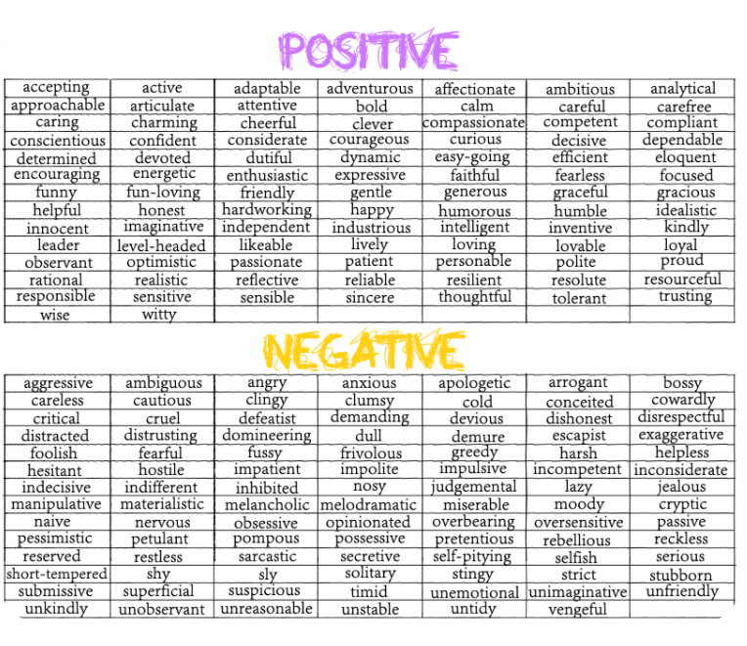

Fun questions? Would you rather have questions few!

1rather like to see 10 min in future or 100 min in past why?

1.eat a whole lemon or bitterguard?

Would you rather be really funny or smart?

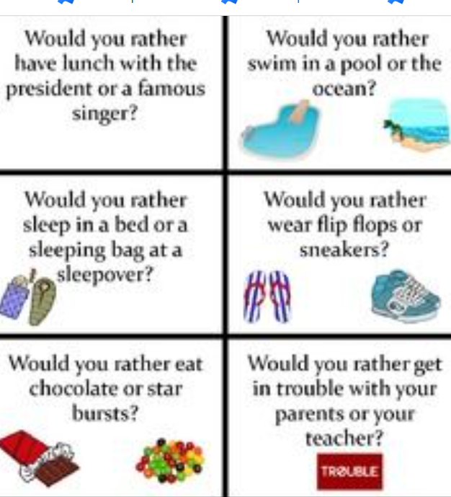

About Coding

Any previous experience with coding if any what is that?

Why would you like to learn coding ? is that parents wish or your wish.

Is there anyone in family who can do coding and help you on that ?

Riddle time

